Practical 3
4.
num = 10
if num >= 0:
result = num ** 0.5
print("Square root:", result)
else:
print("Square root is not defined for negative numbers (real numbers).")
output:
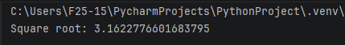

5.
bits = 10
bytes_value = bits / 8
megabytes = bytes_value
gigabytes = bytes_value
terabytes = bytes_value
print("Megabytes (MB):", megabytes)
print("Gigabytes (GB):", gigabytes)
print("Terabytes (TB):", terabytes)
output:
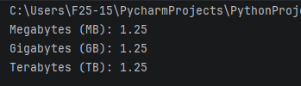

6.
a = 10
b = 20
temp = a
a = b
b = temp
print("After swapping:")
print("a =", a)
print("b =", b)
output:
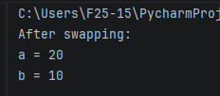

7.
import math
radius = 5
height = 10
surface_area = 2 * math.pi * radius * (radius + height)
volume = math.pi * radius ** 2 * height
print("Surface Area of the Cylinder:", surface_area)
print("Volume of the Cylinder:", volume)
output:
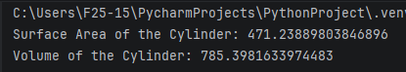

Practical 5
2.
num = 2
while num <= 15:
print(num)
num += 2
output:
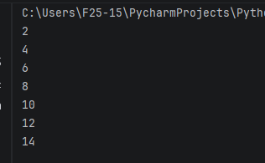

3.
num = 20
reverse = 0
while num > 0:
digit = num % 10
reverse = reverse * 10 + digit
num //= 10
print("Reversed number:", reverse)
output:
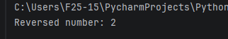

4.
num = 10
factorial = 1
i = 1
while i <= num:
factorial = factorial * i
i += 1
print("Factorial of", num, "is", factorial)
output:
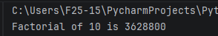

5.
n = 5
a = 0
b = 1
print("Fibonacci series:")
for i in range(n):
print(a, end=" ")
a, b = b, a + b
output:
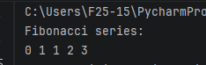

Practical 7
6.
list1 = [1, 2, 3, 4, 5]
list2 = [4, 5, 6, 7, 8]
common = []
for item in list1:
if item in list2:
common.append(item)
print("Common items:", common)
x={"apple","banana","cherry"}
y={"google","microsoft","apple"}
z=x.union(y)
print(z)
x={"apple","banana","cherry"}
y={"google","microsoft","apple"}
z=x.intersection(y)
print(z)
x={"apple","banana","cherry"}
y={"google","microsoft","apple"}
z=x.difference(y)
print(z)
x={"apple","banana","cherry"}
y={"google","microsoft","apple"}
z=x.symmetric_difference(y)
print(z)
dict={'Name':'Zara','Age':7,'Class':'First'}
print("dict['Name']:",dict['Name'])
print("dict['Age']:",dict['Age'])
output:
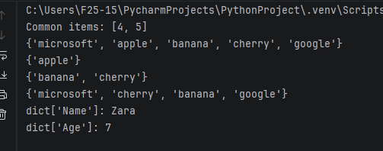
7.
my_list = [1, 2, 3, 4, 5]
my_list.reverse()
print("Reversed list:", my_list)
output:
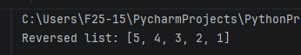

a.
my_list = [10, 20, 30, 40, 50]
print("Created list:", my_list)
output:
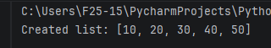

Practical 8
a.
my_list = [10, 20, 30, 40]
print("Length of list:", len(my_list))
output:
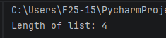

b.
my_str = "hello"
new_list = list(my_str)
print("List from string:", new_list)
output:
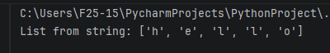

c.
list1 = [1, 2, 3]
list2 = [1, 2, 4]
def cmp(a, b):
return (a > b) - (a < b)
print("Compare lists:", cmp(list1, list2))
output:
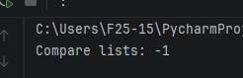

5.
list1 = [1, 2, 3, 4, 5]
list2 = [4, 5, 6, 7, 8]
common_items = []
for item in list1:
if item in list2:
common_items.append(item)
print("Common items:", common_items)
output:
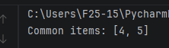
Practical 9
a.
single_tuple = (100,)
print("Single element tuple:", single_tuple)
output:
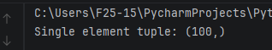
5.
from collections import Counter
my_tuple = (1, 2, 3, 2, 4, 5, 3, 2, 1)
counter = Counter(my_tuple)
print("Repeated items:")
for item, count in counter.items():
if count > 1:
print(item, "appears", count, "times")
output:
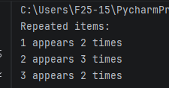

Practical 10
a.
my_set = {10, 20, 30, 40, 50}
print("Created set:", my_set)
output:
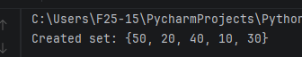

3.
a.
my_set = {10, 20, 30}
print("Initial set:", my_set)
output:
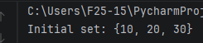
b.

4.
my_set = {10, 20, 30, 40, 50}
max_value = max(my_set)
print("Maximum value in the set:", max_value)
min_value = min(my_set)
print("Minimum value in the set:", min_value)
output:
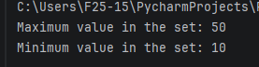

5.
my_set = {10, 20, 30, 40, 50}
set_length = len(my_set)
print("Length of the set:", set_length)
output:
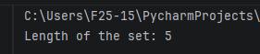

Practical 11
a.
A = {1, 2, 3, 4}
B = {3, 4, 5, 6}
print("Set A:", A)
print("Set B:", B)
Output:
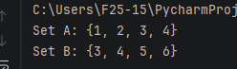
b.

